

Rossmoyne Senior High School

Semester Two Examination, 2016

Question/Answer Booklet

MATHEMATICS

SOLUTIONS
SPECIALIST
UNITS 3 AND 4

Section Two:

Calculator-assumed

Student Number: In figures

In words

Your name

Time allowed for this section
Reading time before commencing work: ten minutes
Working time for section: one hundred minutes

Materials required/recommended for this section
To be provided by the supervisor
This Question/Answer Booklet
Formula Sheet (retained from Section One)

To be provided by the candidate
Standard items: pens (blue/black preferred), pencils (including coloured), sharpener, correction fluid/tape, eraser, ruler, highlighters

Special items: drawing instruments, templates, notes on two unfolded sheets of A4 paper, and up to three calculators approved for use in the WACE examinations

Important note to candidates
No other items may be taken into the examination room. It is your responsibility to ensure that you do not have any unauthorised notes or other items of a non-personal nature in the examination room. If you have any unauthorised material with you, hand it to the supervisor before reading any further.

Structure of this paper

Section | Number of questions available | Number of questions to be answered | Working  time (minutes) | Marks available | Percentage of exam
Section One:  Calculator-free | 8 | 8 | 50 | 52 | 35
Section Two:  Calculator-assumed | 12 | 12 | 100 | 97 | 65
 |  |  | Total | 149 | 100

Instructions to candidates

1. The rules for the conduct of examinations are detailed in the school handbook. Sitting this examination implies that you agree to abide by these rules.

2. Write your answers in this Question/Answer Booklet.

3. You must be careful to confine your response to the specific question asked and to follow any instructions that are specified to a particular question.

4. Spare pages are included at the end of this booklet. They can be used for planning your responses and/or as additional space if required to continue an answer.
- Planning: If you use the spare pages for planning, indicate this clearly at the top of the page.
- Continuing an answer: If you need to use the space to continue an answer, indicate in the original answer space where the answer is continued, i.e. give the page number. Fill in the number of the question that you are continuing to answer at the top of the page.

5. Show all your working clearly. Your working should be in sufficient detail to allow your answers to be checked readily and for marks to be awarded for reasoning. Incorrect answers given without supporting reasoning cannot be allocated any marks. For any question or part question worth more than two marks, valid working or justification is required to receive full marks. If you repeat any question, ensure that you cancel the answer you do not wish to have marked.

6. It is recommended that you do not use pencil, except in diagrams.

7. The Formula Sheet is not to be handed in with your Question/Booklet.

Section Two: Calculator-assumed 65% (97 Marks)
This section has twelve (12) questions. Answer all questions. Write your answers in the spaces provided.

Working time for this section is 100 minutes.

Question 9 (6 marks)
A system of equations is shown below.

$$x+2y+3z=1 \\ y+3z=-1 \\ -y+\left(a^{2}-4\right)z=a+2$$

(a) Determine the unique solution to the system when $a=2$. (2 marks)
Solution
$-y=4⇒y=-4$
$3z=-1+4=3⇒z=1$
$x-8+3=1⇒x=6$
$x=6, y=-4, z=1$

Specific behaviours
substitutes and solves for y
solves for z and x

(b) Determine the value(s) of $a$ so that the system

(i) has an infinite number of solutions. (3 marks)
Solution
$\left(a^{2}-4+3\right)z=a+2-1$
$\left(a+1\right)\left(a-1\right)z=a+1$

Require $a=-1$ for an infinite number of solutions

Specific behaviours
adds row2 and row 3 to eliminate y
factorises $a^{2}-1$
states value of a

(ii) has no solutions. (1 mark)
Solution
Require $a=1$ for no solutions

Specific behaviours
states value of a

Question 10 (8 marks)
The length of time, $T$ months, that an athlete stays in an elite squad can be modelled by a normal distribution with population mean $μ$ and population variance $σ^{2}=15$.

(a) An independent sample of five values of T is $7.7, 15.2, 3.9, 13.4$ and $11.8$months.

(i) Calculate the mean of this sample and state the distribution that a large number of such samples is expected to follow. (2 marks)
Solution
$\overline{x}=\frac{52}{5}=10.4$ months

Sample means normally distributed with mean $μ$ and variance $σ^{2}=\frac{15}{5}=3$ months

Specific behaviours
calculates sample mean
states distribution with mean and variance

(ii) Use this sample to construct a 90% confidence interval for $μ$, giving the bounds of the interval to two decimal places. (3 marks)
Solution
$z=1.645$ for 90% CI

$10.4±1.645×\sqrt{3}$

Interval is $7.55<μ<13.25$ months

Specific behaviours
uses correct z-score
calculates lower bound, rounding
calculates upper bound, rounding

(b) Determine the smallest number of values of T that would be required in a sample for the total width of a 95% confidence interval for $μ$ to be less than 3 months. (3 marks)
Solution
$$z=1.96, σ=\sqrt{15} \\ n={\left(\frac{1.96×\sqrt{15}}{1.5}\right)}^{2}=25.61$$
Smallest sample size is $n=26$

Specific behaviours
shows z-score, variance and interval half-width used
calculates n
rounds n up

Question 11 (7 marks)
Plane $p_{1}$ has equation $3x+y+z=6$ and line l has equation $r=i+j+2k+t(i-2j-k)$.

(a) Show that the line l lies in the plane $p_{1}$. (3 marks)
Solution
$p_{1}$ can be expressed as $r⋅\left[\begin{matrix}3 \\ 1 \\ 1\end{matrix}\right]=6$ and l as $r=\left[\begin{matrix}1+t \\ 1-2t \\ 2-t\end{matrix}\right]$
Then $\left[\begin{matrix}1+t \\ 1-2t \\ 2-t\end{matrix}\right] ⋅\left[\begin{matrix}3 \\ 1 \\ 1\end{matrix}\right]=6$

Which simplifies to $3+3t+1-2t+2-t=6$ and then to $6=6$

Hence line lies in plane.

Specific behaviours
writes plane in vector form
substitutes line into plane equation
simplifies and draws conclusion

(b) Another plane, $p_{2}$, is perpendicular to plane $p_{1}$, parallel to the line l and contains the point with position vector $i-3j-k$. Determine the equation of plane $p_{2}$, giving your answer in the form $ax+by+cz=d$. (4 marks)
Solution
$p_{2}$ must contain vectors $\left[\begin{matrix}3 \\ 1 \\ 1\end{matrix}\right]$ and $\left[\begin{matrix}1 \\ -2 \\ -1\end{matrix}\right]$
$n=\left[\begin{matrix}3 \\ 1 \\ 1\end{matrix}\right]×\left[\begin{matrix}1 \\ -2 \\ -1\end{matrix}\right]=\left[\begin{matrix}1 \\ 4 \\ -7\end{matrix}\right]$
$r⋅n=\left[\begin{matrix}1 \\ 4 \\ -7\end{matrix}\right]⋅\left[\begin{matrix}1 \\ -3 \\ -1\end{matrix}\right]=-4$
Hence equation of $p_{2}$ is $r⋅\left[\begin{matrix}1 \\ 4 \\ -7\end{matrix}\right]=-4⇒x+4y-7z=-4$

Specific behaviours
uses two vectors in the plane
calculates normal using cross product
obtains vector equation of $p_{2}$
writes plane in required form

Question 12 (13 marks)
(a) Show that the gradient of the curve $2x^{2}+y^{2}=3xy$ at the point $(1, 2)$ is $2$. (3 marks)

Solution
$2(2)x+2yy'=3y+3xy'$
$x=1,y=2⇒4+4y^{'}=6+3y^{'}⇒y^{'}=2$

Specific behaviours
correctly differentiates LHS
correctly differentiates RHS
substitutes x and y values and simplifies to show gradient

(b) Another curve passing through the point $\left(-2, 10\right)$ has gradient given by $\frac{dy}{dx}=\frac{2xy}{1+x^{2}}$.
Use a method involving separation of variables and integration to determine the equation of the curve. (4 marks)
Solution
$$\int{\frac{1}{y}}dy=\int{\frac{2x}{1+x^{2}}}dx \\ \ln{y}=\ln\left(1+x^{2}\right)+c \\ y=k(1+x^{2}) \\ y=10, x=-2⇒k=2 \\ y=2(1+x^{2})$$

Specific behaviours
separates variables
integrates both sides
eliminates natural logs
determines constant and writes solution

(c) A particle is moving along the curve given by $y=\sqrt[3]{x}$, with one unit on both axes equal to one centimetre. When $x=1$, the y-coordinate of the position of the particle is increasing at the rate of 2 centimetres per second.

(i) Show that the x-coordinate is increasing at 6 centimetres per second at this instant.
(2 marks)
Solution
$$\frac{dy}{dx}=\frac{1}{3}x^{-\frac{2}{3}} \\ \frac{dx}{dt}=\frac{dx}{dy}×\frac{dy}{dt}=3{(1)}^{\frac{2}{3}}×2=6 \text{cm/s}$$

Specific behaviours
uses chain rule
shows substitution of x-coordinate and given rate

(ii) Determine the exact rate at which the distance of the particle from the origin is changing at this instant. (4 marks)
Solution
$$D=\sqrt{x^{2}+y^{2}}=\sqrt{x^{2}+x^{\frac{2}{3}}} \\ \frac{dD}{dx}=\frac{3x^{\frac{4}{3}}+1}{3\sqrt[3]{x}\sqrt{x^{2}+x^{\frac{2}{3}}}} \\ x=1⇒\frac{dD}{dx}=\frac{2\sqrt{2}}{3} \\ \frac{dD}{dt}=\frac{dD}{dx}×\frac{dx}{dt}=\frac{2\sqrt{2}}{3}×6=4\sqrt{2} \text{cm/s}$$

Specific behaviours
determines expression for distance in terms of one variable
differentiates expression wrt to variable
substitutes, using chain rule
simplifies in exact form

Question 13 (8 marks)
(a) Sketch the graph of $y=\frac{2x+1}{x+1}$ on the axes below. (2 marks)

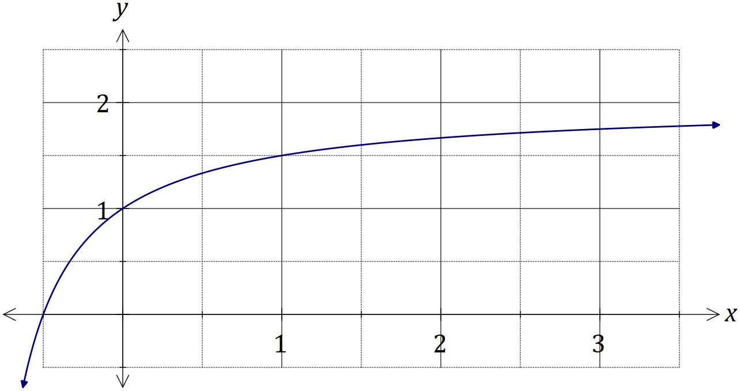
Solution
See graph
Specific behaviours
axes intercepts and (1, 1)
smooth curve

Simpson's rule is a formula used for numerical integration, the numerical approximation of definite integrals. When an interval $[a_{0}, a_{n}]$ is divided into an even number, $n$, of smaller intervals of equal width $w$, the bounds of these smaller intervals are denoted $a_{0}, { a}_{1}, a_{2},…, a_{n-1}, { a}_{n}$. Simpson's rule can be expressed as follows:

$$\int_{a_{0}}^{a_{n}}{f(x)}dx=\frac{w}{3}(B+2E+4O)$$

where $B=f(a_{0})+f(a_{n})$, $E$ is the sum of the values of $f\left(a_{k}\right)$ where $k$ is even and $O$ is the sum of the values of $f\left(a_{k}\right)$ where $k$ is odd.

(b) Use Simpson's rule with $n=6$ to evaluate an approximation for $\int_{0}^{3}{\frac{2x+1}{x+1}}dx$, correct to four decimal places. (4 marks)
Solution
$a_{0}=1, a_{1}=\frac{4}{3}, a_{2}=\frac{3}{2}, a_{3}=\frac{8}{5}, a_{4}=\frac{5}{3}, a_{5}=\frac{12}{7}, a_{6}=\frac{7}{4}$

$B=\frac{11}{4}, E=\frac{19}{6}, O=\frac{488}{105}$

$\frac{1/2 }{3}\left(\frac{11}{4}+2×\frac{19}{6}+4×\frac{488}{105}\right)=\frac{11623}{2520}≈4.6123$

Specific behaviours
calculates ordinates
calculates B, E and O
evaluates using rule
accurate to 4 dp

(c) Determine the exact value of $\int_{0}^{3}{\frac{2x+1}{x+1}}dx$ and hence calculate the percentage error of the approximation from (b). (2 marks)
Solution
$\int_{0}^{3}{\frac{2x+1}{x+1}}dx=6-2\ln{2}$. Hence $\frac{\left(\left(6-2\ln{2}\right)-\frac{11623}{2520}\right)}{6-2\ln{2}}×100≈0.03\%$ error.

Specific behaviours
calculates exact value
calculates % error

Question 14 (7 marks)
(a) The equation of a sphere with centre at $(2, -3, 1)$ is $x^{2}+y^{2}+z^{2}=ax+by+cz-2$.

Determine the values of $a, b, c$ and the radius of the circle. (3 marks)
Solution
Expanding ${\left(x-2\right)}^{2}+{\left(y+3\right)}^{2}+{\left(z-1\right)}^{2}=r^{2}$

Gives $x^{2}+y^{2}+z^{2}-4x+6y-2z+14=r^{2}$

Hence $a=4, b=-6, c=2$ and $r^{2}-14=-2⇒r=\sqrt{12}=2\sqrt{3}$

Specific behaviours
uses standard circle form and expands
states values of a, b and c
determines radius

(b) Two particles, P and Q, leave their initial positions at the same time and travel with constant velocities shown in the table below.

Particle | Initial position | Velocity
P | $$10i-5j+5k$$ | $$6i+2j-4k$$
Q | $$28i+22j-31k$$ | $$2i-4j+4k$$

Show that the two particles collide, stating the position vector of the point of collision.
(4 marks)
Solution
$r_{P}=\left[\begin{matrix}10+6t \\ -5+2t \\ 5-4t\end{matrix}\right]$ , $r_{Q}=\left[\begin{matrix}28+2t \\ 22-4t \\ -31+4t\end{matrix}\right]$

Solving $10+6t=28+2t⇒ t=4.5$.

$r_{P}(4.5)=\left[\begin{matrix}37 \\ 4 \\ -13\end{matrix}\right]$ , $r_{Q}(4.5)=\left[\begin{matrix}37 \\ 4 \\ -13\end{matrix}\right]$

Hence collide at $37i+4j-13k$ when $t=4.5$

Specific behaviours
states vector equations of both paths
solves for $t$ using one pair of coefficients
substitutes to show both have same position
states position vector of point of collision

Question 15 (8 marks)
(a) Briefly describe a reason that a sample rather than a complete population may be used when carrying out a statistical investigation. (1 mark)
Solution
Cheaper, Quicker, Easier, etc.

Specific behaviours
any legitimate reason

(b) A researcher used government records to select a random sample of the ages of 114 men who had died recently in a town close to an industrial complex. The mean and standard deviation of the ages in the sample were 73.3 and 8.27 years respectively.

(i) Explain why the sample standard deviation is a reasonable estimate for the population standard deviation in this case. (1 mark)
Solution
The sample size is large and well above 30.

Specific behaviours
states large sample size

(ii) Calculate a 98% confidence interval for the population mean and explain what the interval shows. (4 marks)
Solution
z-score for 98% interval is 2.326
$73.3±2.326×\frac{8.27}{\sqrt{114}}=\left(71.5, 75.1\right)$
We are 98% confident that the true mean lies between 71.5 and 75.1 years.

Specific behaviours
uses correct z-score
demonstrates calculation used to calculate interval
calculates correct interval
explains interval

(iii) The national average life-span of men was known to be 75.3 years. State with a reason what conclusion the researcher could draw from the confidence interval calculated in (ii) about the life-span of men in the town. (2 marks)
Solution
There is a significant difference in life-span of men in the town from those nationally, as the interval does not contain 75.3.

Specific behaviours
notes interval does not contain 75.3
uses 'difference' and 'lifespan' in explanation

Question 16 (8 marks)
(a) On the Argand diagram below, clearly show the region that satisfies the complex inequalities given by $\left|z+3-4i\right|≤5$ and $\frac{π}{2}≤\arg{z}≤π$. (4 marks)

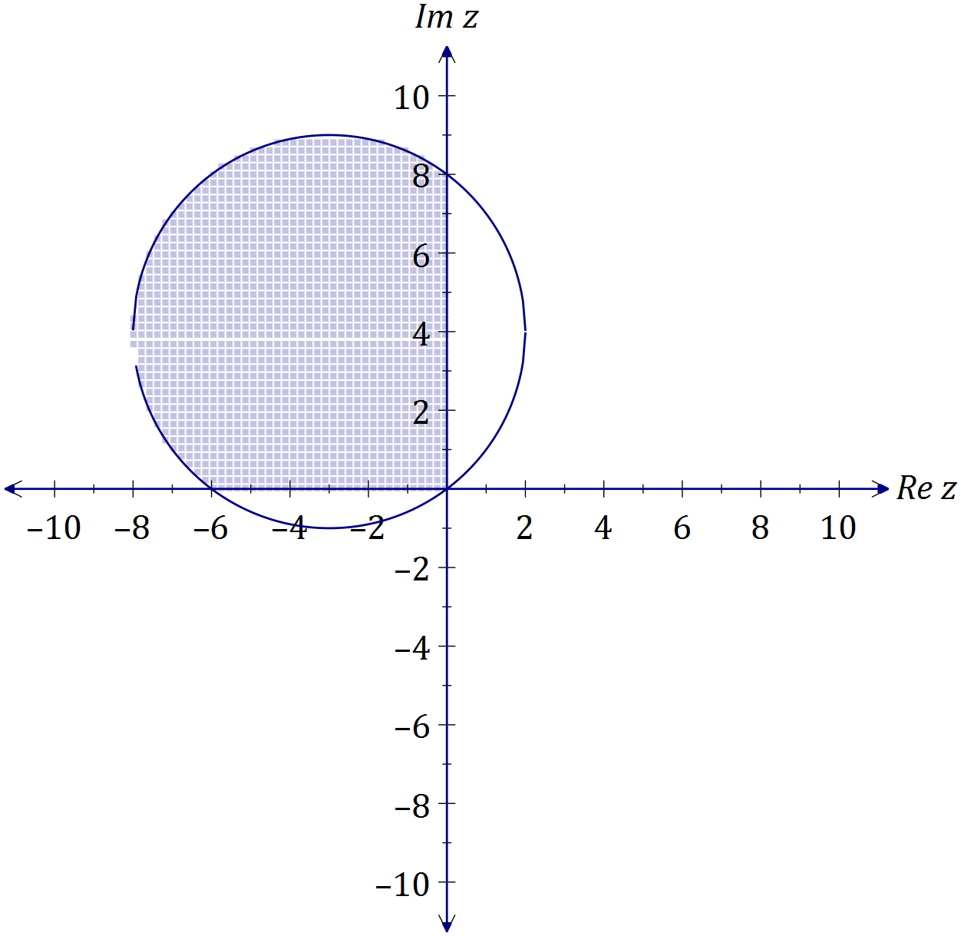
Solution
See diagram, $\left|z-(-3+4i)\right|≤5$

Specific behaviours
circle with centre (-3,4) and radius 5
circle intercepts at (0,0), (0,8), (-6,0)
shades inside circle
only shades in second quadrant

(b) Determine all roots of the equation $z^{5}=16\sqrt{3}+16i$, expressing them in the form $r\operatorname{cis}{θ}$, where $r≥0$ and $-π≤θ≤π$. (4 marks)
Solution
$z^{5}=32\operatorname{cis}{\frac{π}{6}}$
$z_{1}=2\operatorname{cis}\left(\frac{π}{30}\right)$
$z_{2}=2\operatorname{cis}\left(\frac{13π}{30}\right)$
$z_{3}=2\operatorname{cis}\left(\frac{25π}{30}\right)$
$z_{4}=2\operatorname{cis}\left(\frac{-11π}{30}\right)$
$z_{5}=2\operatorname{cis}\left(\frac{-23π}{30}\right)$

Specific behaviours
expresses $z^{5}$ in polar form
determines first root
determines other two roots with positive arguments
determines other two roots with negative arguments

Question 17 (7 marks)
The graph of $y=f(x)$ is shown below, where $f\left(x\right)={4cos}^{4}{(2x)}$ and A is the smallest root of $f\left(x\right), x>0$.

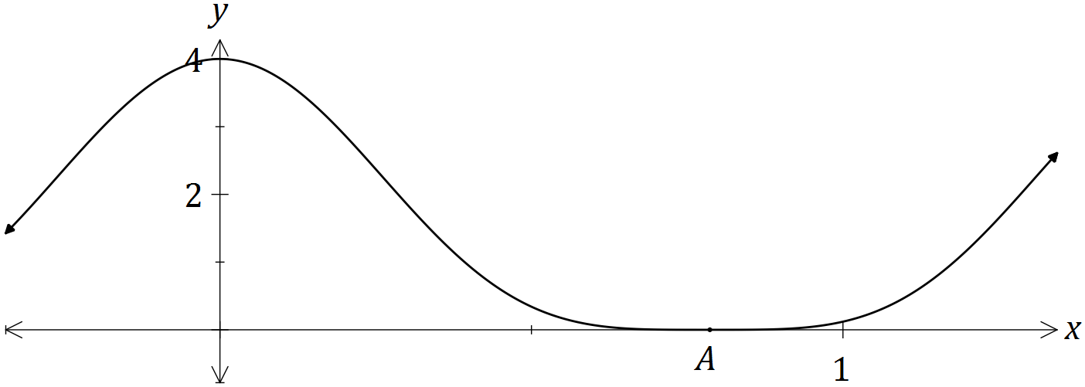

(a) Show that ${4cos}^{4}{(2x)}=\frac{3+4\cos{(4x)}+\cos{(8x)}}{2}$. (3 marks)
Solution
$$4\cos^{4}\left(2x\right)={{4(cos}^{2}{(2x))}}^{2} \\ ={4\left(\frac{1+\cos{4x}}{2}\right)}^{2} \\ =1+2\cos{4x}+\cos^{2}{4x} \\ =1+2\cos{4x}+\frac{1+\cos{8x}}{2} \\ =\frac{3+4\cos{(4x)}+\cos{(8x)}}{2}$$

Specific behaviours
uses double angle identity
expands and uses identity again
simplifies as required

(b) Hence determine $\int{{4cos}^{4}{(2x)}}dx$. (2 marks)
Solution
$$\int{\frac{3+4\cos{(4x)}+\cos{(8x)}}{2}}dx=\frac{3x}{2}+\frac{1}{2}\sin{4x}+\frac{1}{16}\sin{8x}+c$$

Specific behaviours
uses result from (a) to integrate
obtains correct result, including constant

(c) Determine the exact volume of the solid generated when the region bounded by $=f\left(x\right),$ $y=0$, $x=0$ and $x=A$ is rotated through 360° about the x-axis.
(2 marks)
Solution
$\int_{0}^{\frac{π}{4}}{π}{\left(4\cos^{4}\left(2x\right)\right)}^{2}dx=\frac{35π^{2}}{32}$ cubic units

Specific behaviours
writes integral
evaluates integral in exact form

Question 18 (10 marks)
(a) A small object has initial position vector $r\left(0\right)=i+3j-k$ metres and moves with velocity vector given by $v\left(t\right)=2ti-4tj+3k$ ms⁻¹, where $t$ is the time in seconds.

(i) Show that the acceleration of the object is constant and state the magnitude of the acceleration. (2 marks)
Solution
$a\left(t\right)=2i-4j$ - hence constant acceleration.

$\left|a\right|=\sqrt{2^{2}+4^{2}}=2\sqrt{5}$ ms⁻²

Specific behaviours
differentiates velocity
evaluates magnitude

(ii) Determine the position vector of the object after 2 seconds. (3 marks)
Solution
$r\left(t\right)=t^{2}i-2t^{2}j+3tk+const$

$r\left(0\right)=i+3j-k⇒r\left(t\right)=\left(t^{2}+1\right)i+(3-2t^{2})j+(3t-1)k$

$r\left(2\right)=\left(2^{2}+1\right)i+\left(3-2{\left(2\right)}^{2}\right)j+\left(3\left(2\right)-1\right)k=5i-5j+5k$

Specific behaviours
integrates velocity
uses initial condition
determines position vector

(b) Another small object has position vector given by $r\left(t\right)=\left(1+2\sec{t}\right)i+\left(3\tan{t}-2\right)j$ m, where $t$ is the time in seconds.

(i) Determine the distance of the object from the origin when $t=\frac{π}{3}$. (2 marks)
Solution
$\left|r\left(\frac{π}{3}\right)\right|=\left|\left(1+2\sec{\frac{π}{3}}\right)i+\left(3\tan{\frac{π}{3}}-2\right)j\right|=\left|5i+\left(3\sqrt{3}-2\right)j\right|$

Distance is 5.93 m (2 decimal places)

Specific behaviours
substitutes $\frac{pi}{3}$ and simplifies
determines magnitude

(ii) Derive the Cartesian equation of the path of this object. (3 marks)
Solution
$$x=1+2\sec{t} , y=3\tan{t}-2$$

$$\sec^{2}{t}-\tan^{2}{t}=1⇒{\left(\frac{x-1}{2}\right)}^{2}-{\left(\frac{y+2}{3}\right)}^{2}=1$$

Specific behaviours
equates x and y components
uses trig identity
rearranges and substitutes correctly

Question 19 (7 marks)
(a) A particle undergoing simple harmonic motion with a period of 5 seconds is observed to move in a straight line, oscillating 3.6 m either side of a central position. Determine the speed of the particle when it is 3 m from the central position. (3 marks)
Solution
$$ω=\frac{2π}{5} \\ v^{2}={\left(\frac{2π}{5}\right)}^{2}\left({3.6}^{2}-3^{2}\right) \\ \left|v\right|=2.50 \text{m/s}$$

Specific behaviours
determines $ω$
substitutes into velocity equation
evaluates speed

(b) Another particle moving in a straight line experiences an acceleration of $x+2.5$ ms⁻², where $x$ is the position of the particle at time $t$ seconds.

Given that when $x=1$, the particle had a velocity of 2 ms⁻¹, determine the velocity of the particle when $x=2$. (4 marks)

Solution
$$\frac{1}{2}v^{2}=\int{x+2.5}dx \\ v^{2}=2\left(\frac{x^{2}}{2}+2.5x\right)+c \\ x=1, v=2⇒c=-2 \\ x=2⇒v^{2}=2\left(\frac{2^{2}}{2}+2.5(2)\right)-2⇒v=±2\sqrt{3}$$

Specific behaviours
uses appropriate form of acceleration
integrates
evaluates constant
states all possible values of v

Question 20 (8 marks)
The complex numbers $w$ and $z$ are given by $-\frac{1}{2}-\frac{\sqrt{3}}{2}i$ and $r(\cos{θ}+i\sin{θ})$ respectively, where $r>0$ and $-\frac{π}{3}<θ<\frac{π}{3}$.

(a) State, in terms of $r$ and $θ$, the modulus and argument of $wz$ and $\frac{z}{w}$. (3 marks)
Solution
$w=\operatorname{cis}{\frac{-2π}{3}}$ , $z=r\operatorname{cis}{θ}$

$wz=r\operatorname{cis}\left(θ-\frac{2π}{3}\right)⇒$ modulus is r and argument is $θ-\frac{2π}{3}$

$\frac{z}{w}=r\operatorname{cis}\left(θ-\frac{-2π}{3}\right)⇒$ modulus is r and argument is $θ+\frac{2π}{3}$

Specific behaviours
expresses w in cis form
forms product and expresses modulus and argument
forms quotient and expresses modulus and argument

(b) Explain why the points represented by $z$, $wz$ and $\frac{z}{w}$ in an Argand diagram are the vertices of an equilateral triangle. (2 marks)
Solution
The points are all at distance r from the origin and all subtend angles of $\frac{2π}{3}$ at the origin.

Specific behaviours
states equidistant from origin (or shows with diagram)
states subtend equal angles at origin (or shows with diagram)

(c) In an Argand diagram, one of the vertices of an equilateral triangle is represented by the complex number $5-\sqrt{3}i$. If the other two vertices lie on a circle with centre at the origin, determine the complex numbers they represent in exact Cartesian form. (3 marks)
Solution
Let $z=5-\sqrt{3}i$ then other two vertices will be
$wz=-4-2\sqrt{3}i$ and
$\frac{z}{w}=-1+3\sqrt{3}i$

Specific behaviours
realises to use z
determines first vertex
determines second vertex

Additional working space

Question number: _________

Additional working space

Question number: _________

© 2016 WA Exam Papers. Rossmoyne Senior High School has a non-exclusive licence to copy and communicate this paper for non-commercial, educational use within the school. No other copying, communication or use is permitted without the express written permission of WA Exam Papers.

